INTERNATIONAL DAY OF YOGA (21. 06. 2023)
International Day of Yoga was Celebrated by organizing an event on 21 June 2023. Cadets performed yoga Asanas, Surya namaskars and emphasized the Importance of the mental and physical health through yoga. It was Attended by many prominent professors and students are join the Great enthusiasm.
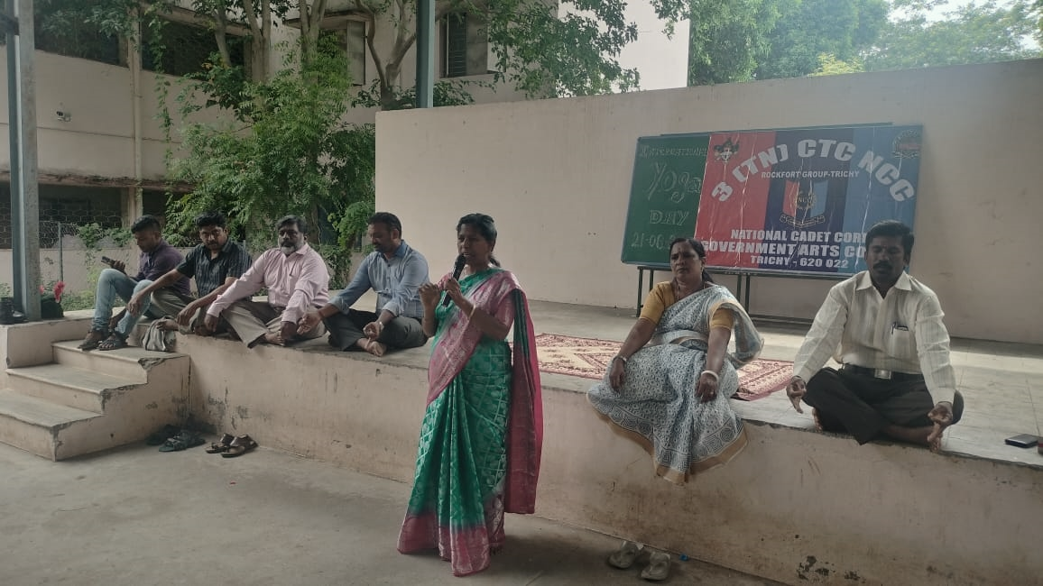
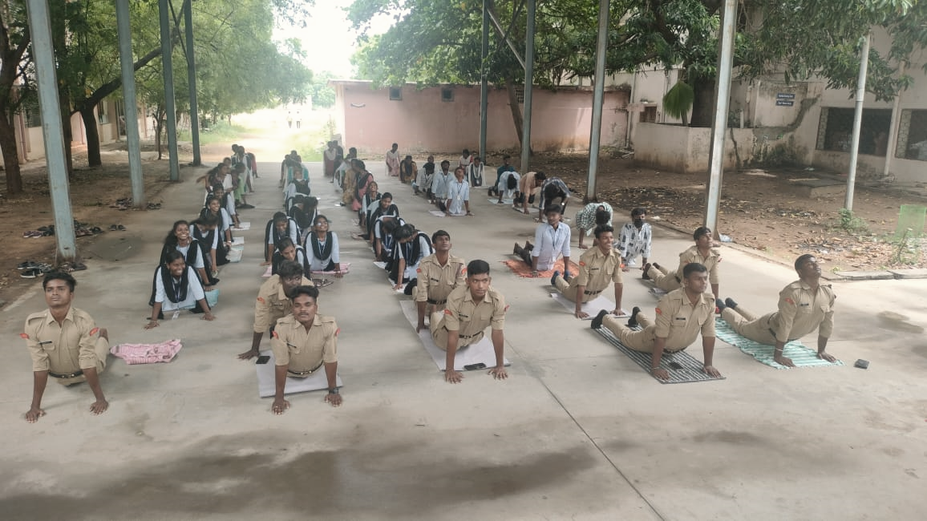
INTERNATIONAL DAY AGAINST DRUG ABUSE AND ILLICIT TRAFFICKING 2023 (26. 06. 2023)
June 26th - As an expression of determination to strengthen action against drug abuse and in order to create awareness in the society against drug use and trafficking, the NCC unit of Our college conducted a rally at Anna Arch and spent time with street vendors and small business owners about the efficacies of drug abuse. Cadets hung up posters highlighting various slogans such as “Say no to drugs”. Cadets also addressed the vendors about the side effects to health due to drug use. Promises and oaths were taken to never encourage use of drugs or indulge in drug trafficking by the vendors and sellers.
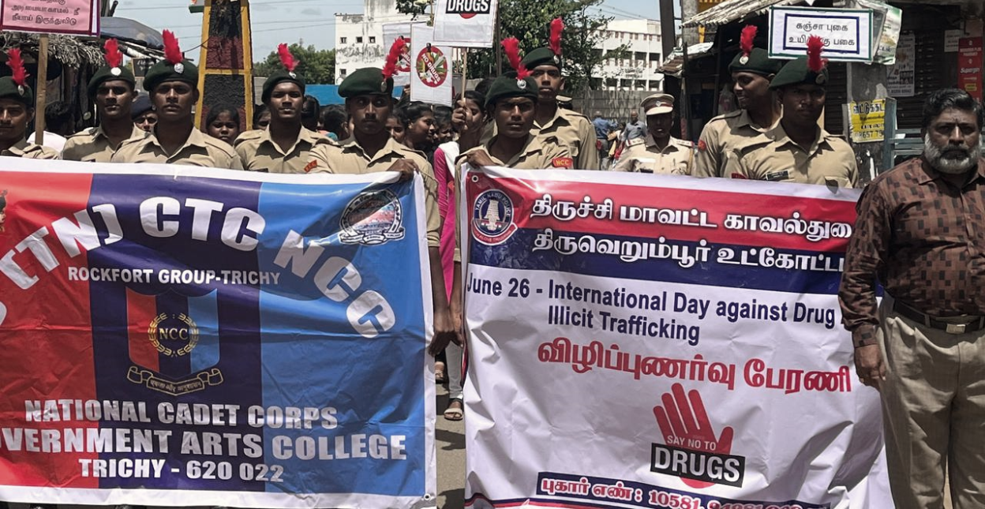

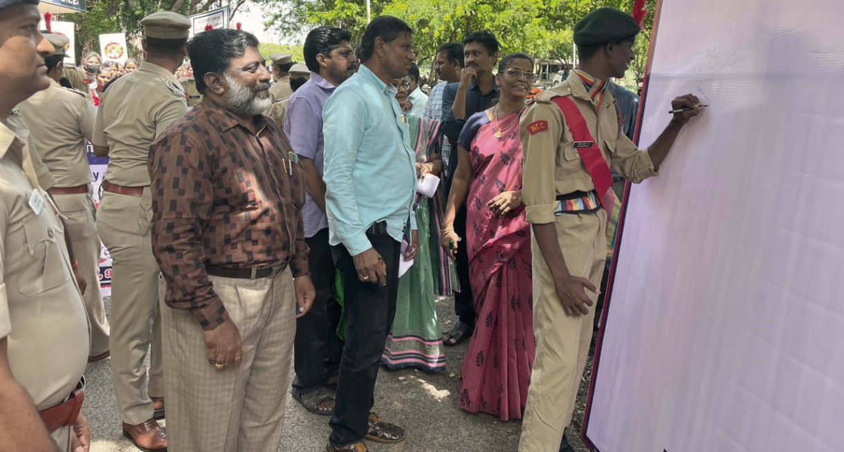

CLEANING OF WATER BODIES
(17. 11. 2023)
Thuvakudi Government Arts College NCC Unit Organized a Programme “Cleaning Water Bodies” in the premises of VaalavanthaankottaiVillage Panchayat, Aayarpaadi Pond on 17th November 2023. The Cleaning work was started on morning 10 am. On this day All the Cadets in the presence the ANO Dr. J. Prabhakaran Everyone participated Actively in Cleaning Aayarpaadi Pond and pond Surroundings. There were Plastic Covers, Unwanted Plants and All other Wastes which was a bit difficult to clean up but all the Cadets shown their interest and dedication towards cleaning their surroundings. The Collected Wastes are given for the municipality through Garbage Vehicle to Dispose properly.
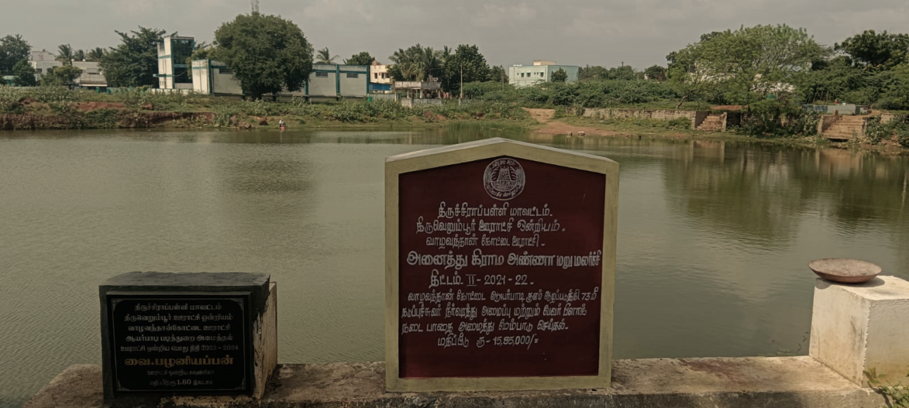
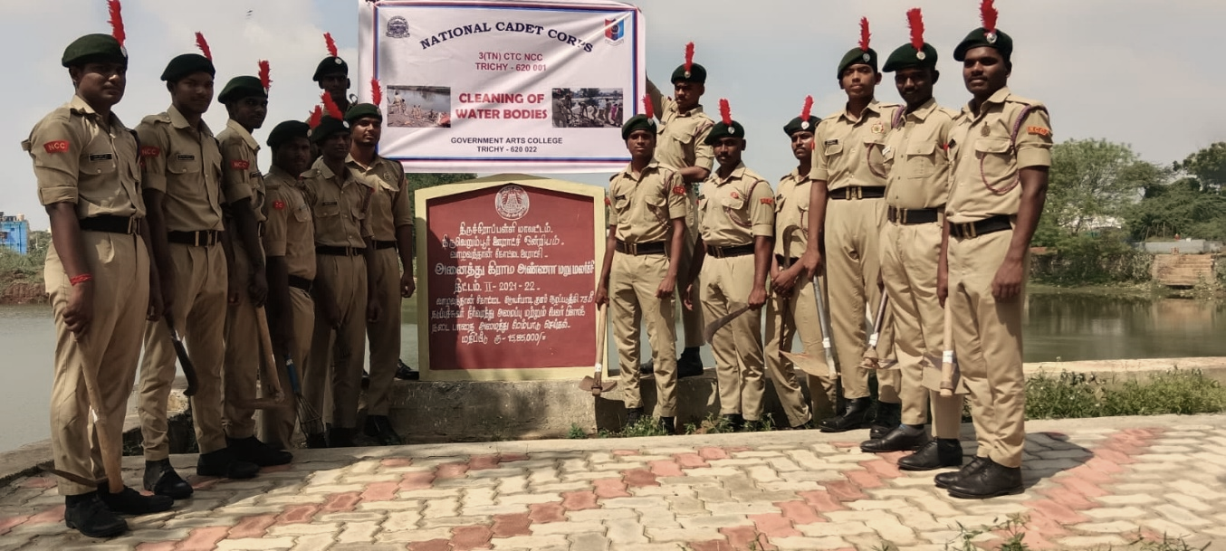
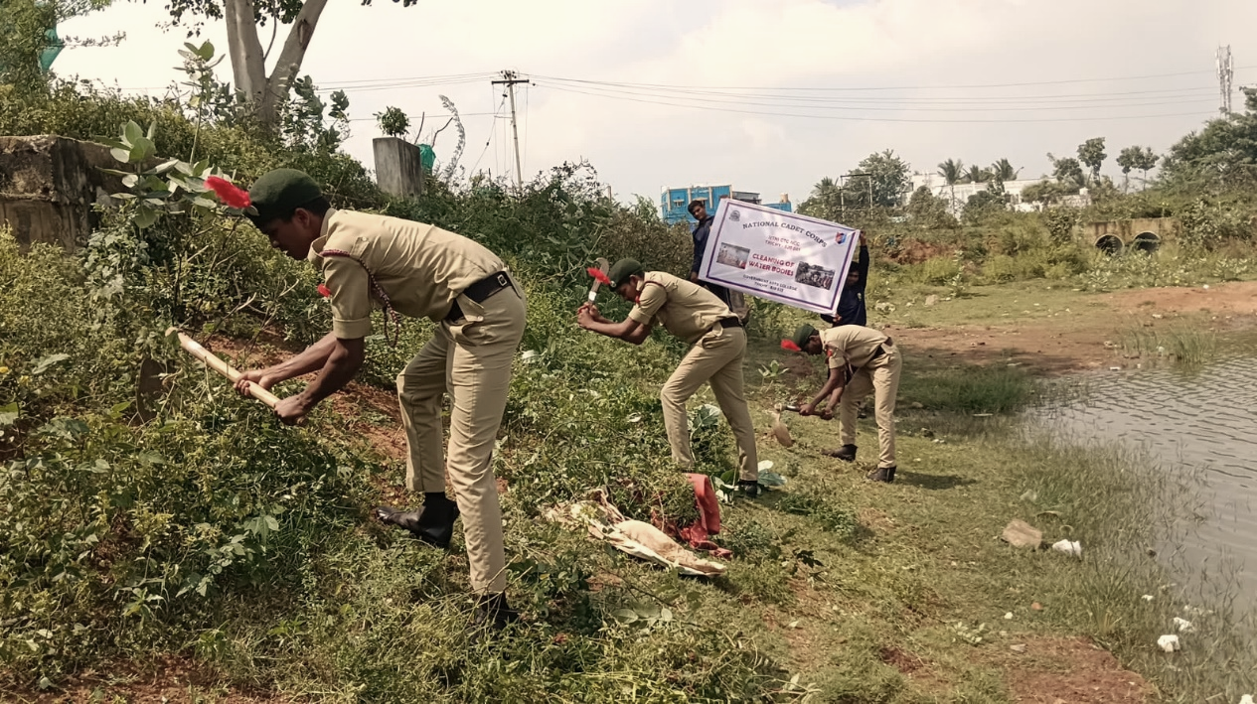
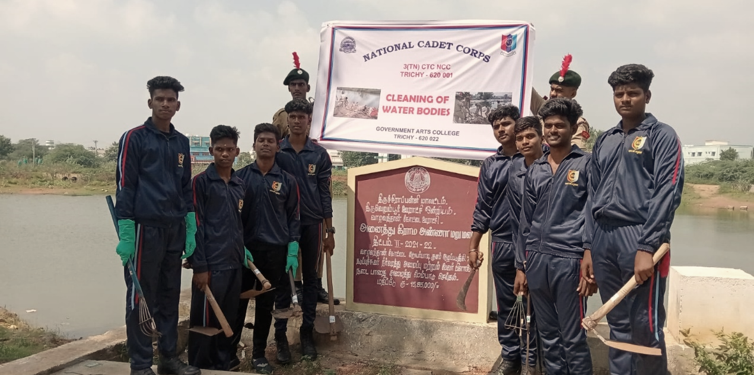

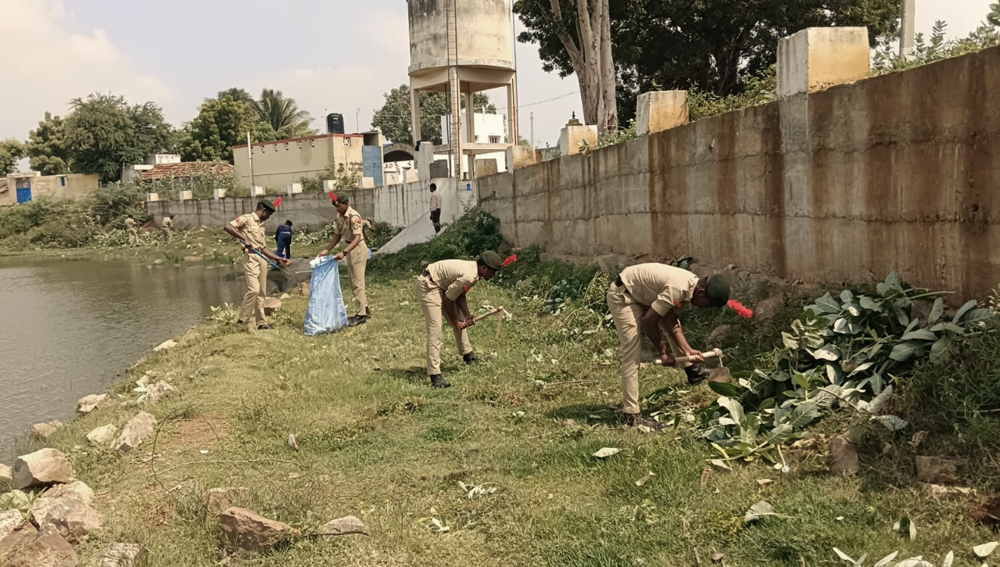
BLOOD DONATION PROGRAMME
(17. 11. 2023)
As a part of NCC day 2023 (17. 11. 2023), NCC cadets of Government Arts College, Trichy – 22 donate Blood to Blood Bank of BHEL Main Hospital, Trichy - 14. Number of cadets participated: 05. The Blood Donors were given Banana, Biscuits and Frooti after donating the Blood in order to reenergize themselves. The Blood Donars were provided with a Blood Donation Certificate by BHEL Main Hospital.

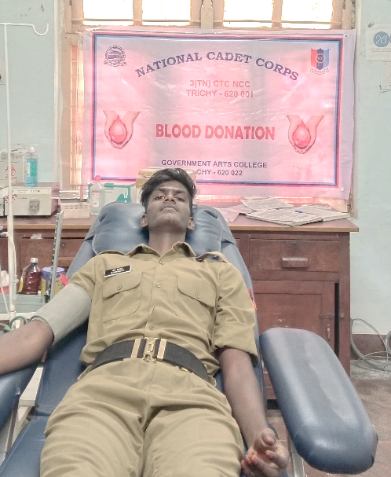
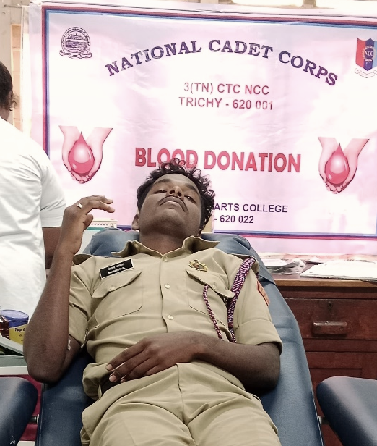
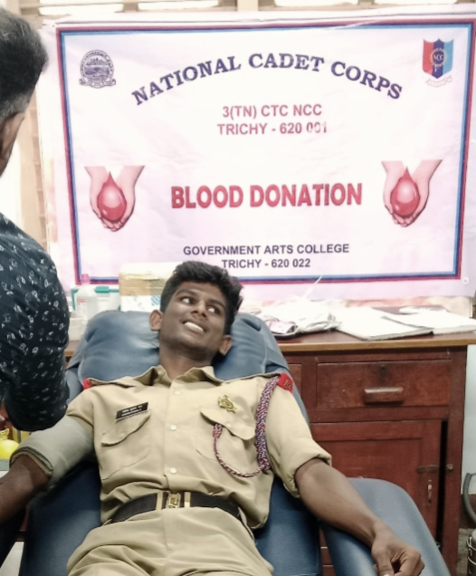

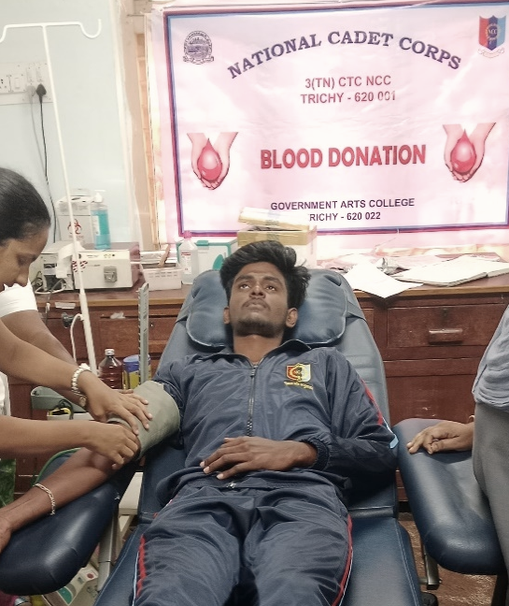
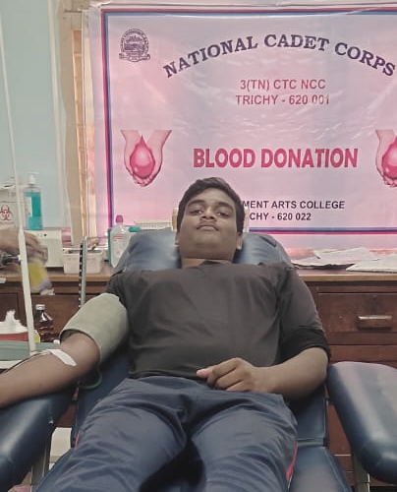

CAMP REPORT
COMBINED ANNUAL TRAINING CAMP CUM TSC/IUC (ALL WINGS)
KUMBAKONAM (12. 06. 2023 – 21. 06. 2023)

7 Cadets From Our College NCC Unit are attended CATC Camp CUM TSC/IUC (ALL WINGS) Conducted by 8(TN) Battalion NCC Kumbakonam at Annai College of Arts & Science, Kovilacheri – 621 503 From 12 June 2023 to 21 June 2023.

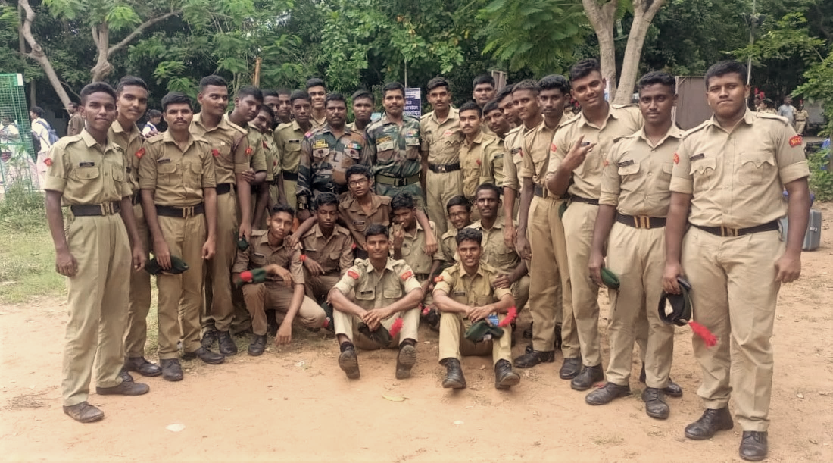

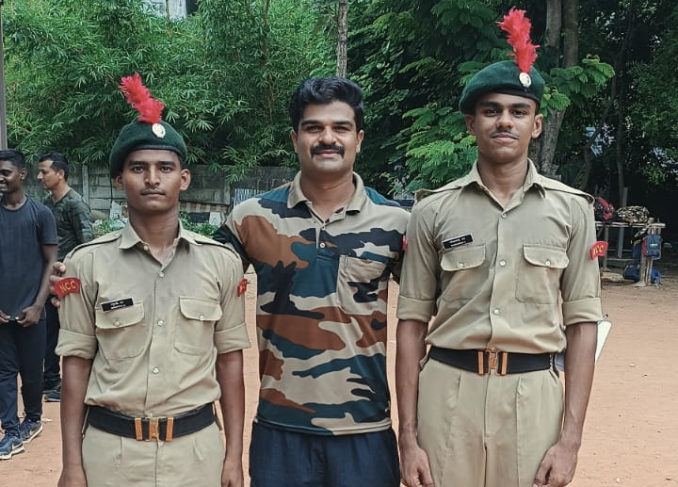

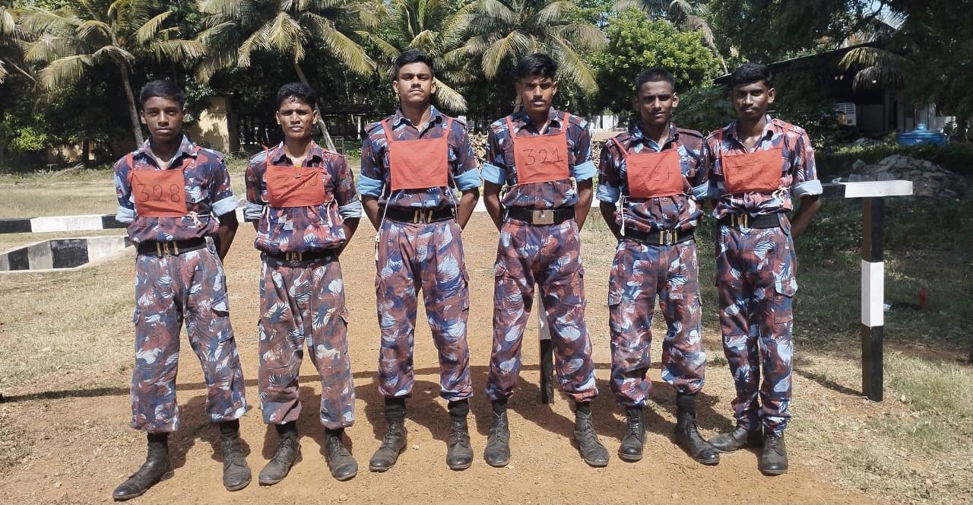
EK BHARAT SHRESHTHA BHARAT – I CAMP (2023)
(03. 08. 2023 – 14. 08.2023)
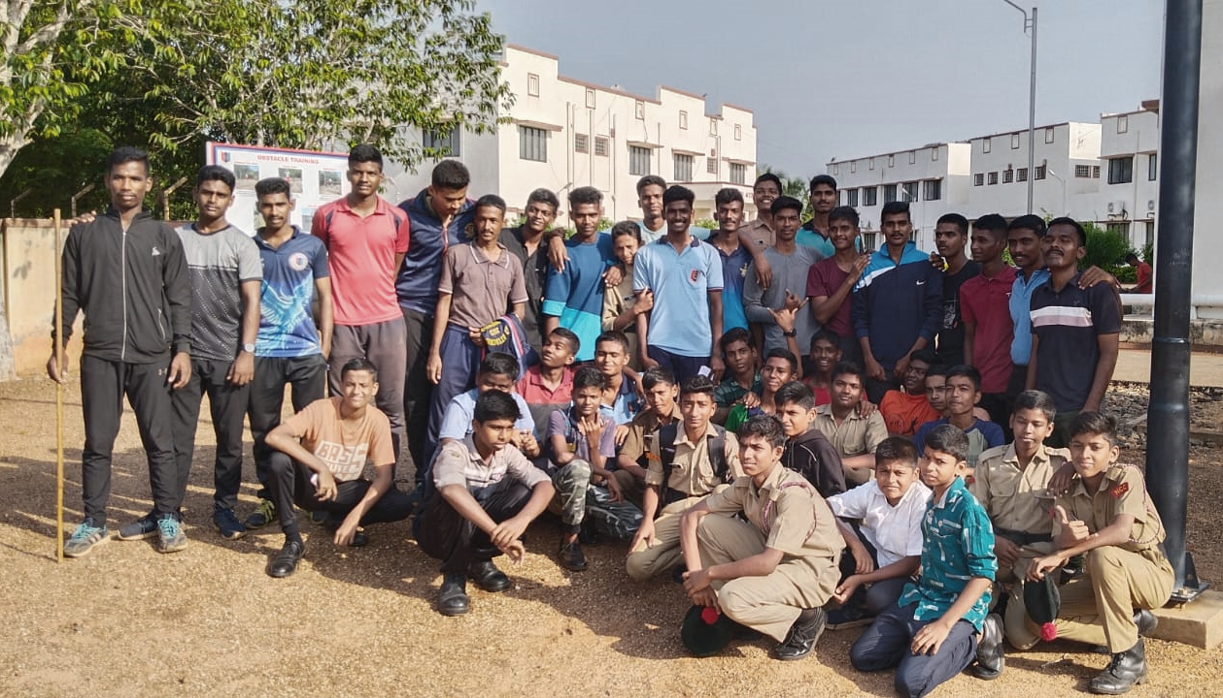
2 Cadets From Our College NCC Unit are attended EK BHARAT SHRESHTHA BHARAT – I CAMP at NCC Training Area, Idayapatti (Madurai) From 03rd Augest 2023 to 14th Augest 2023 Conducted by NCC Group Tiruchirappalli.
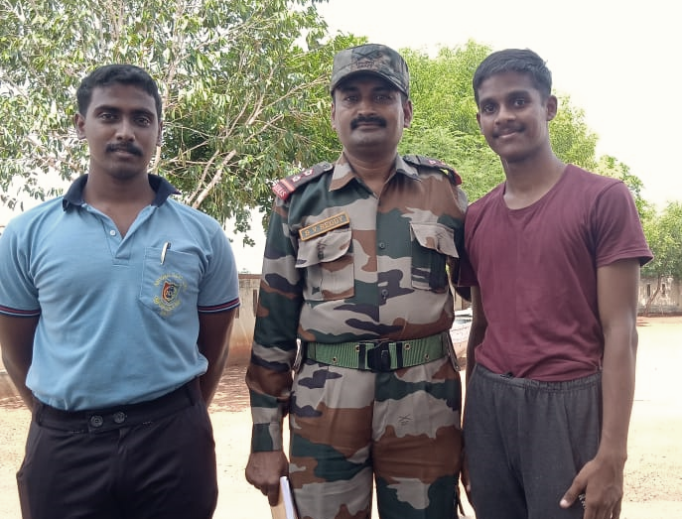

CATC CUM IUC RDC SELECTION CAMP
(11. 08. 2023 – 20 . 08. 2023)
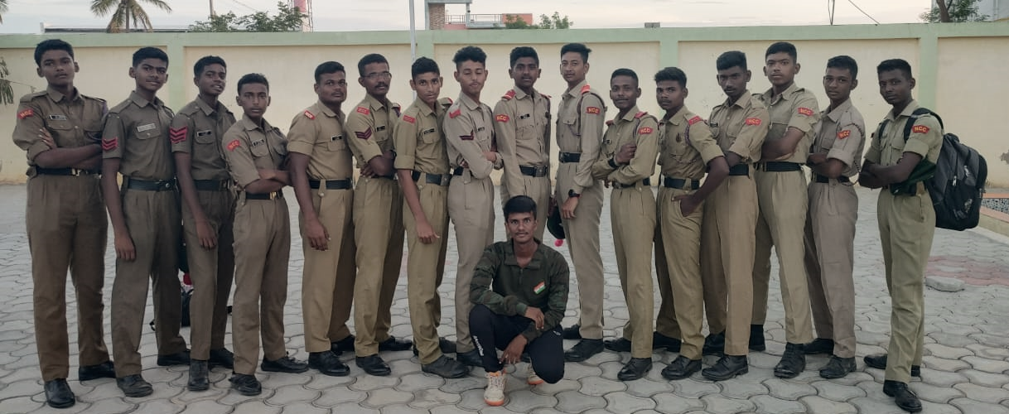
01 Cadet From Our College NCC Unit are attended CATC CUM IUC RDC SELECTION CAMP at Sree Vee College, Dindigul From 11th Augest 2023 to 20th Augest.

CATC CUM GROUP RDC TRAINING – I CAMP
(08. 09. 2023 – 17. 09. 2023)
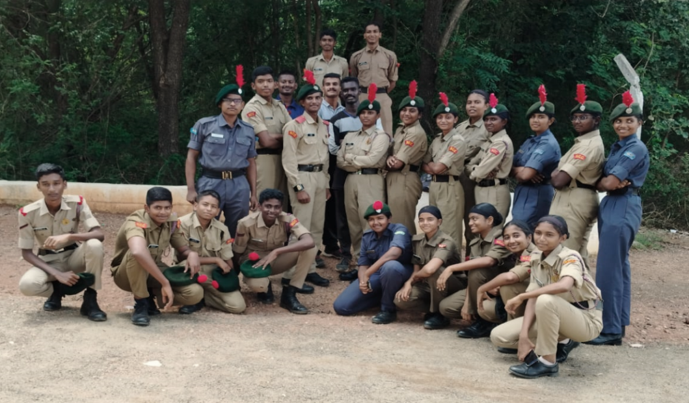
01Cadet From Our College NCC Unit has attendedthe CATC CUM GROUP RDC TRAINING – I CAMP At Anna University (BIT Campus), Mandaiyur, Tiruchirappalli From 08th September 2023 to 17th September 2023 Conducted By 2(TN) Bn NCC, Tiruchirappalli.
ATC / CATC CAMP
(21. 09. 2023 – 30. 09. 2023)
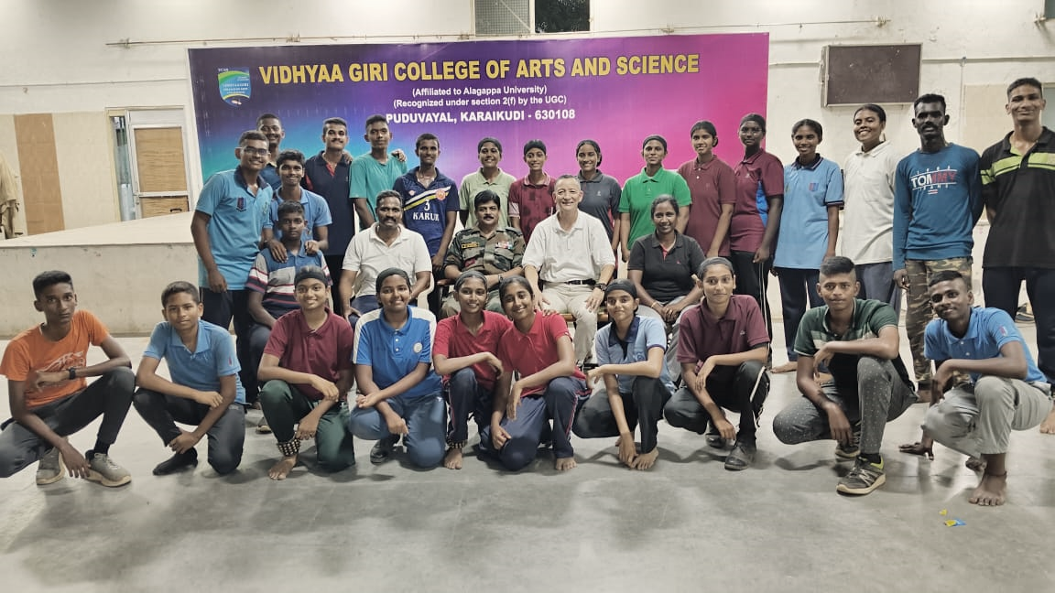
01 Cadet From Our College NCC Unit has attendedthe ATC/ CATC CAMP At Periyar Maniammai Institute of Science & Technology, Vallam Conducted by 4 (TN) Girls BN NCC, Tiruchirappalli. From 21 September 2023 to 30 September 2023.

ATC-II – CUM – GP RDC LAUNCH CAMP
(01.10 . 2023 – 10. 10. 2023)
- 01 Cadet From Our College NCC Unit has attendedthe ATC-II – CUM – GP RDC LAUNCH CAMP for SD NCC Cadets at Shri Vidhyaa Giri Matriculation Higher Secondary School, Pudhuvayal, Karaikudi from 01st October 2023 to 10th October 2023.
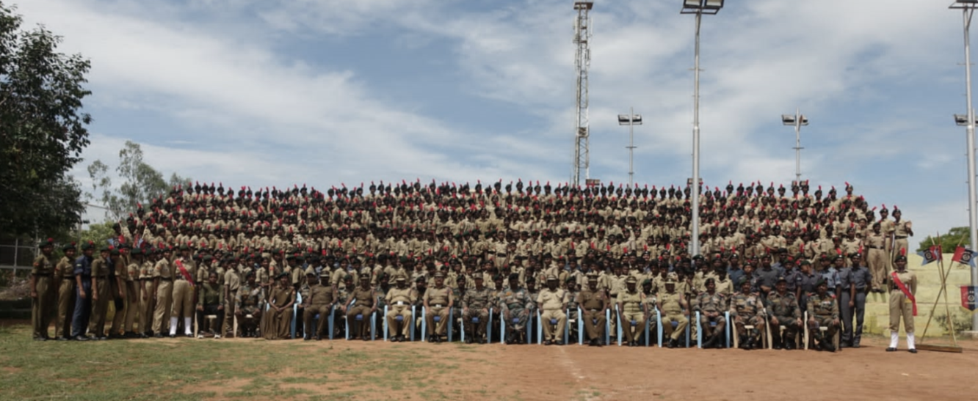
CATC – CUM– IGC – RDC – 2023
(11. 10. 2023 – 20. 10. 2023)
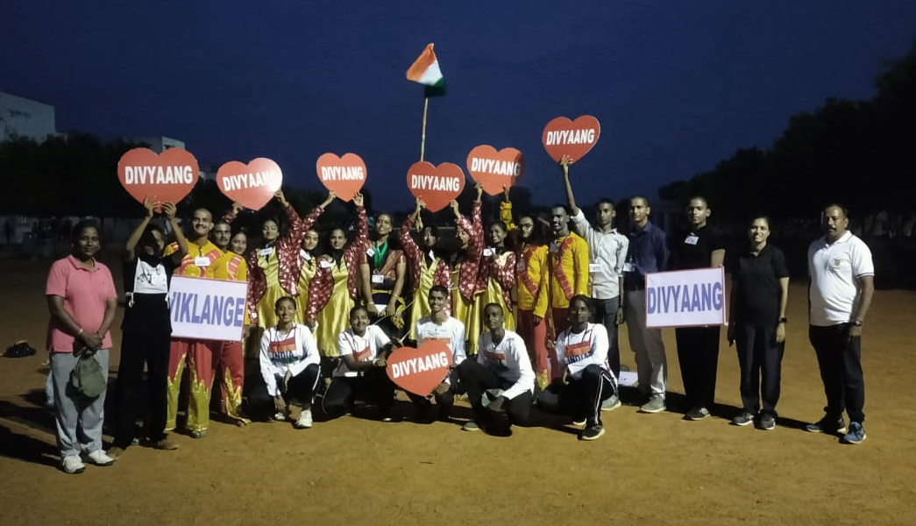
01 Cadet From Our College NCC Unit has attendedthe CATC-CUM-IGC-RDC-2023 held at NTA, Idayapatti, Madurai District from 11th October 2023 to 20th October 2023.

ANNUAL TRAINING CAMP
(28. 09 .2023 – 07. 10. 2023)
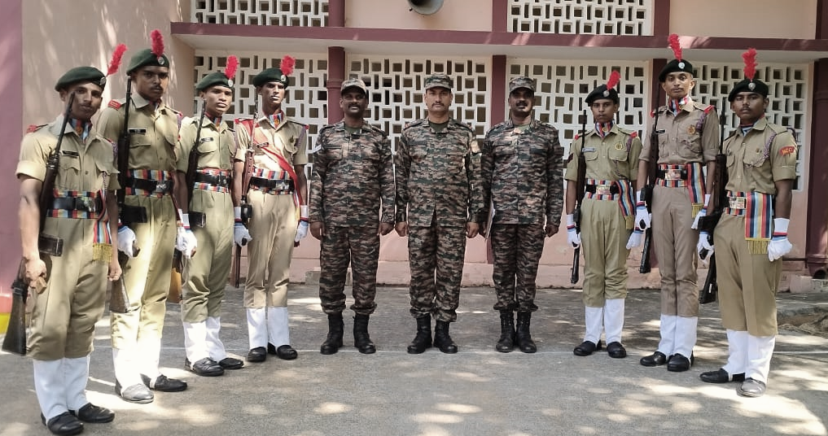
08 Cadets From Our College NCC Unit are attended theANNUAL TRAINING CAMP at Boiler Plant Boys Higher Secondary School, Kailasapuram, Tiruchirappalli From 28th September 2023 to 7th October 2023conducted by 3 (TN) Composite Technical Company NCC, Tiruchirappalli.

SHIVAJI TRIL TREK - 2023
1 Cadet From Our College NCC Unit is attended The SHIVAJI TRIL TREK 2023 at Kolhapur, Maharashtra From 18th November 2023 to 25th November 2023 conducted by Maharashtra Directorate.
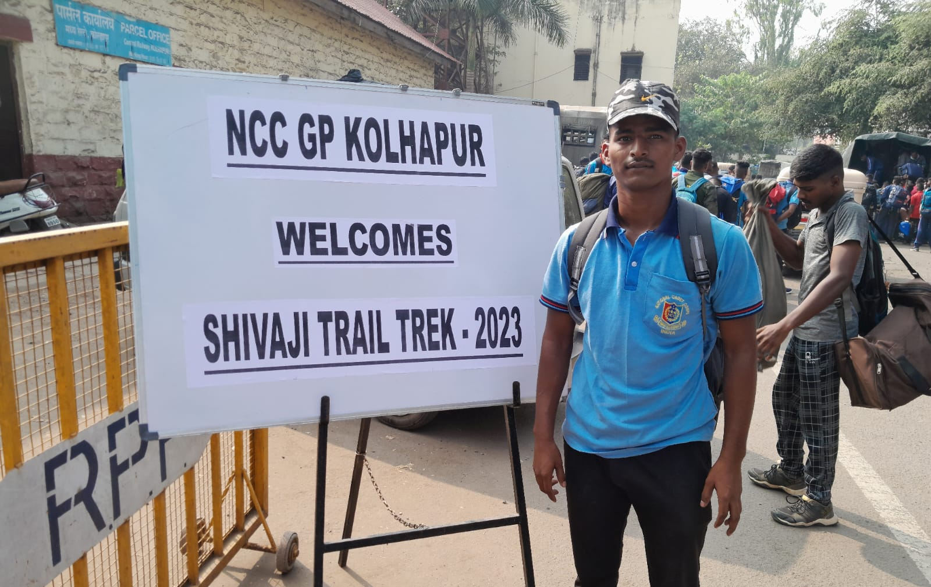

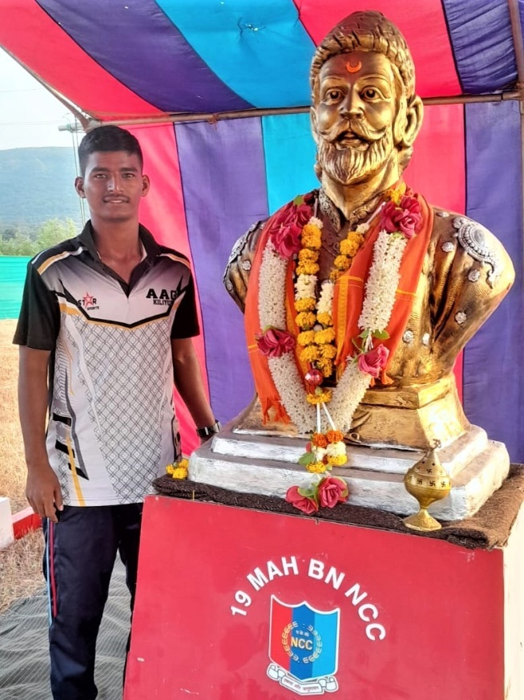
ARMY ATTACHMENT CAMP – 2023 – 2024
1 Cadet From Our College NCC Unit is attended The ARMY ATTACHMENT CAMP – 2023 – 2024 held at 2nd Lancers (GH) From 27th December 2023 to 07th January 2024 .
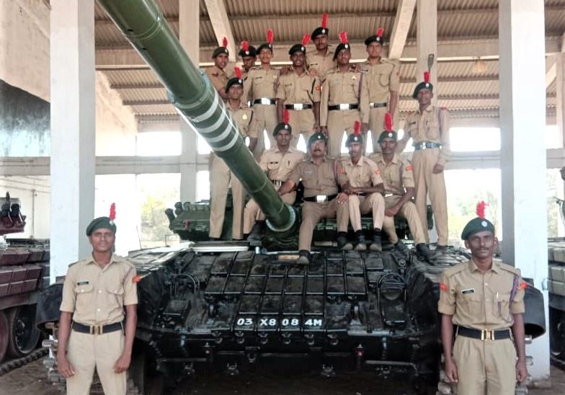

CATC CUM MRDC – I (2024)
1 Cadet From Our College NCC Unit is attended The CATC CUM MRDC – I (2024) held at Jeppiar University, Semmancheri From 03rd January 2024 to 12th January 2024 .
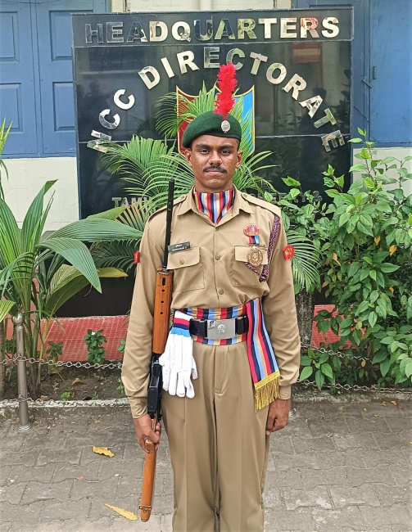

MRDC - 2024 – CHENNAI
1 Cadet From Our College NCC Unit was taken a part in Marching Contingent During Marina Republic Day Parade held in Chennai at 26 January, 2024
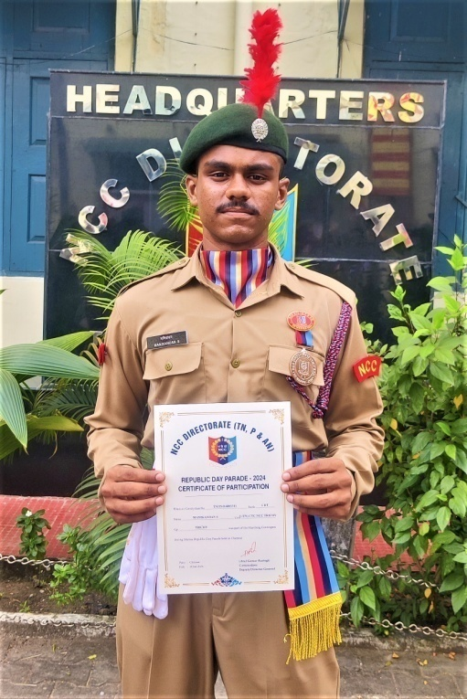
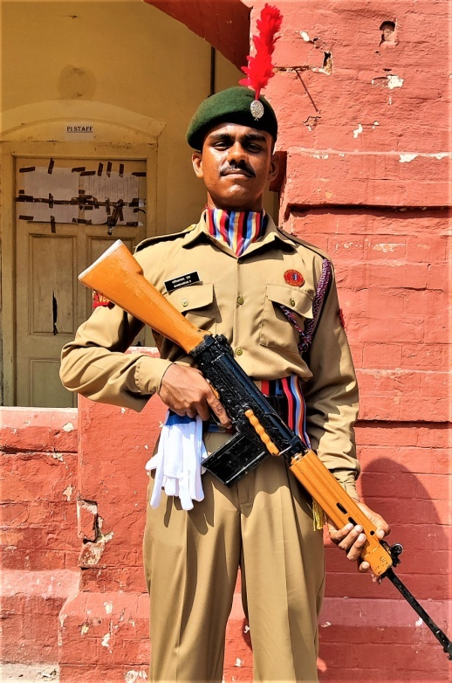

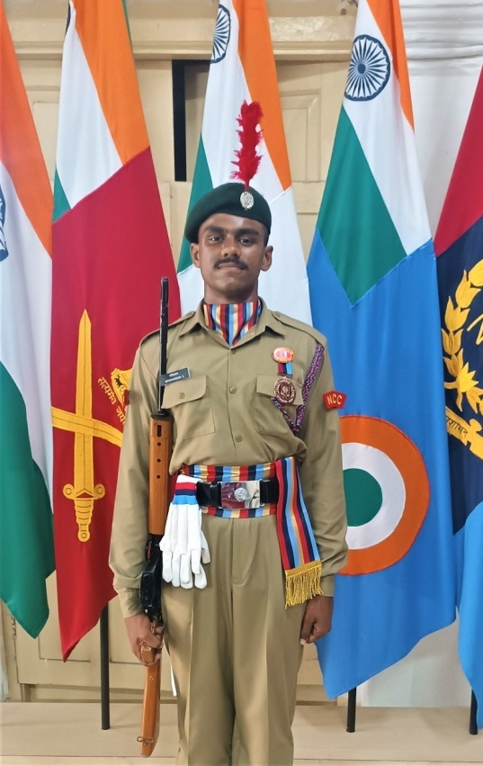
WEAPON TRAINING
(FIRING)
3 Cadets From Our College NCC Unit is attended Weapon Training (firing) at Bharathidasan University Conducted by 3 TN CTC NCC, Rockfort Group TN, P & AN at 11th January, 2024.
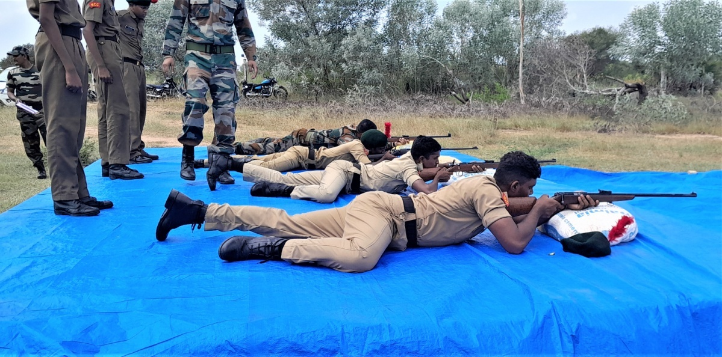

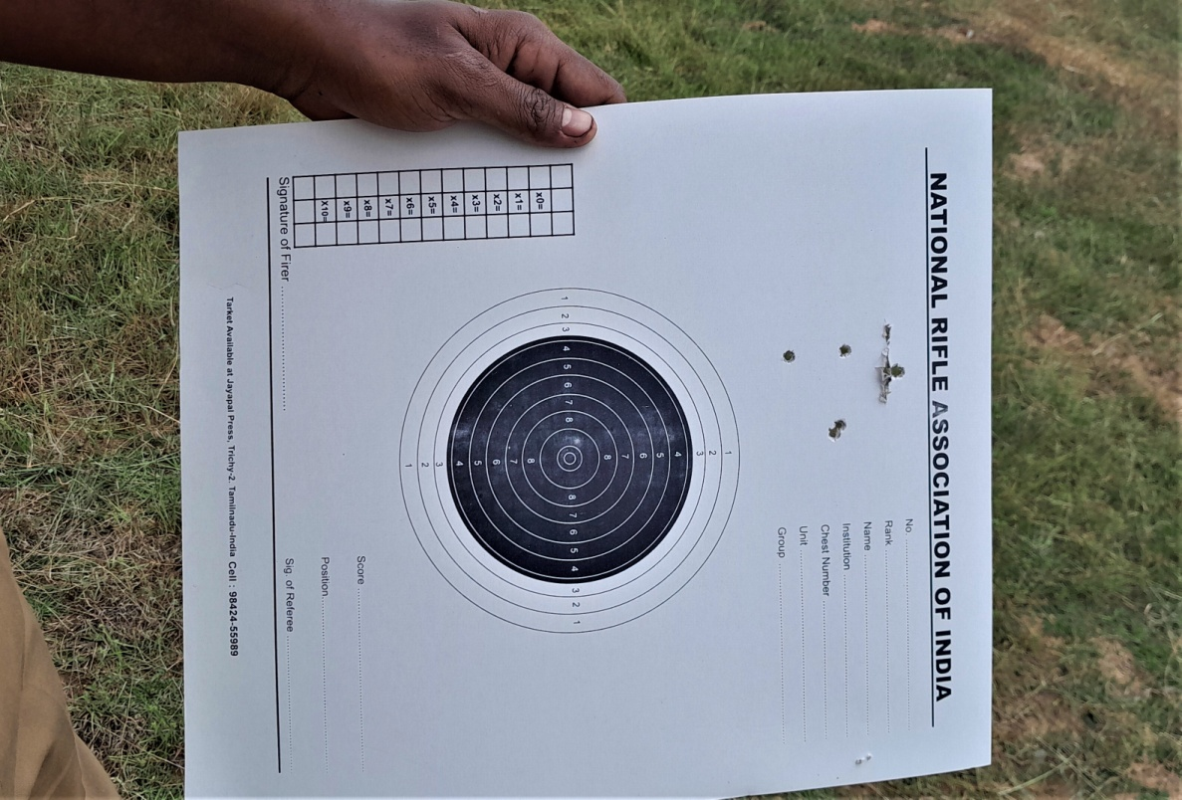

OUR COLLEGE GOLDEN JUBLIEE CELEBRATION
GUARD OF HONOUR
(28. 10. 2023)
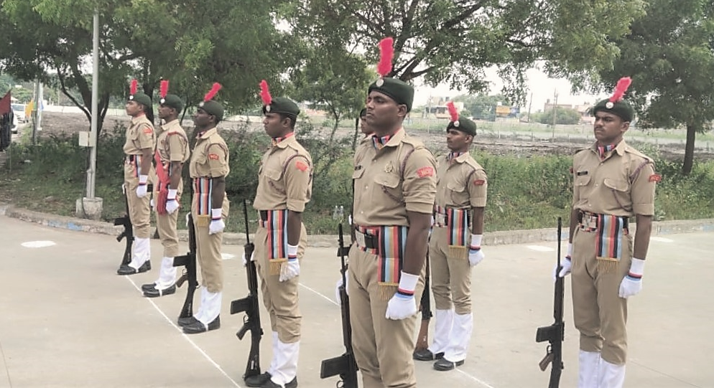
On October 28,2023 Celebrations were held for Golden Jubilee Year of Our Government Arts College, Trichy - 22.NCC Cadets of Our College Actively participated in College Golden Jubilee Celebration Programmes and Paid Guard of Honour to Dr. G. Geetha, Director of Collegiate Education (F.A.C) where she Inspected the Parade and Received Guard of Honour.
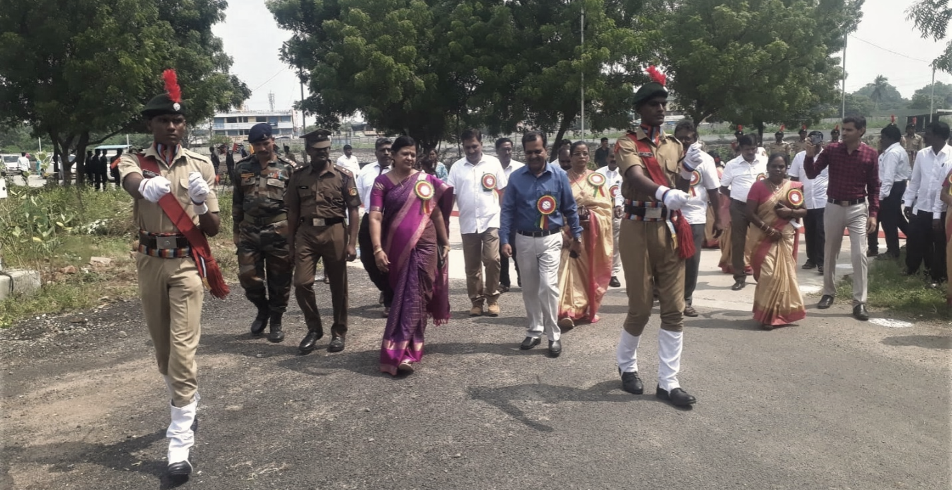
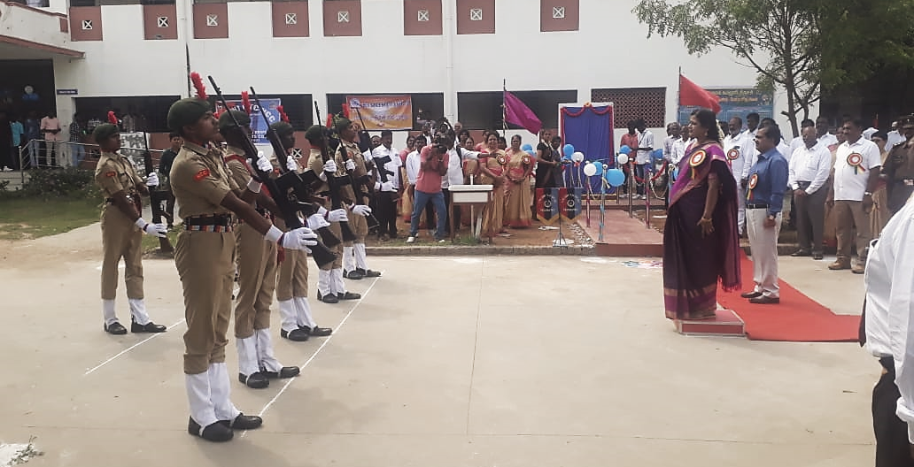

MUTHAMIZH VIZHA 2023
(16. 02. 2023)
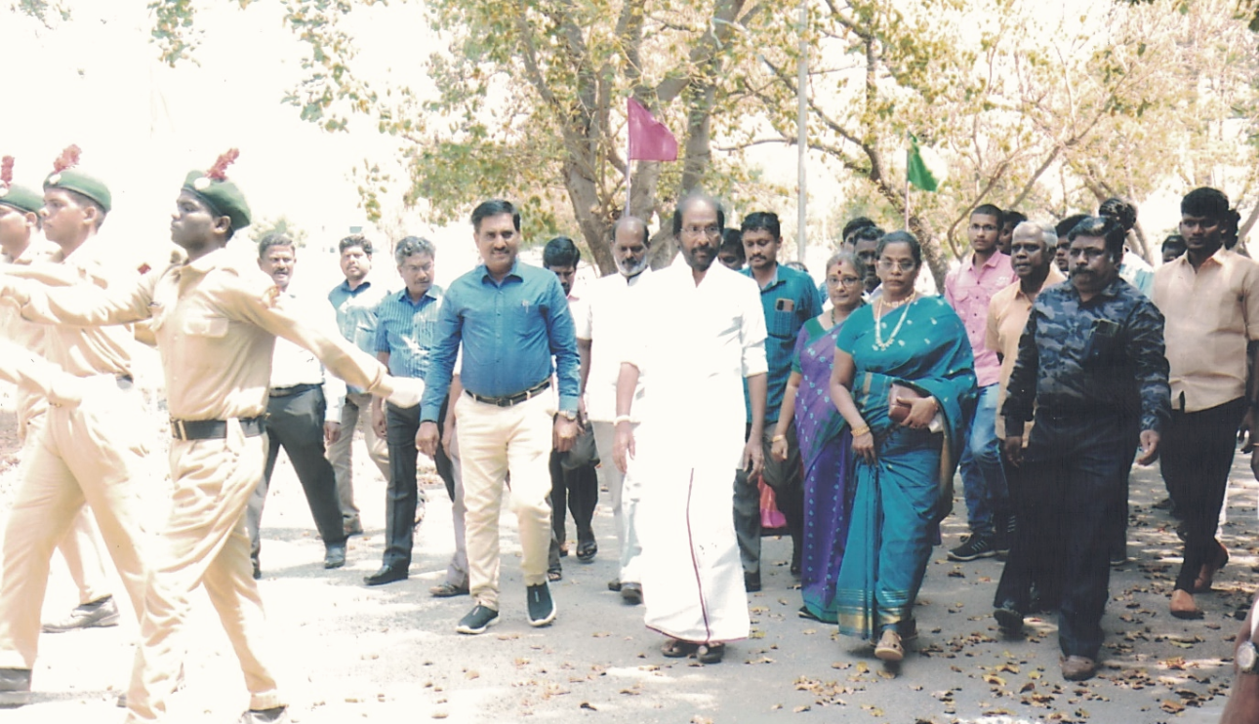
On 16. 02. 2023 MuthamizhVizha was co-organized by tamizhmandram and Fine arts. Tiruchi N. Siva , A Member of Parliament of India Representing Tamilnadu in the Rajya Sabha was the Chief Guest. All NCC Cadets Honored to our Chief Guest.

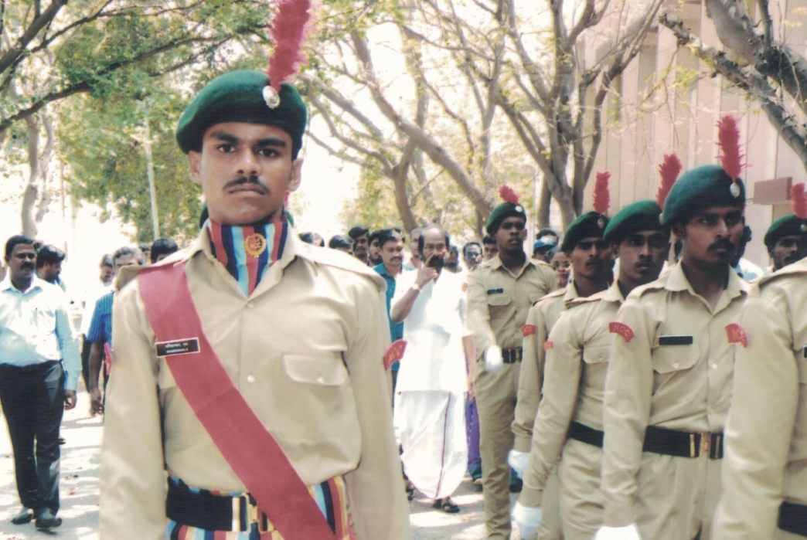

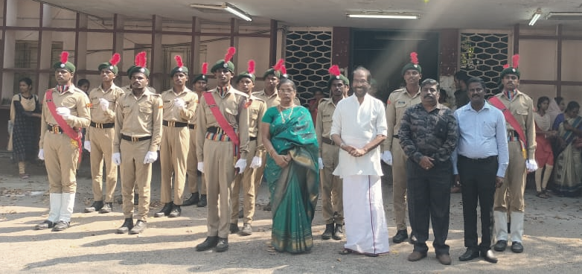
SPORTS DAY 2023
(17. 03. 2023)
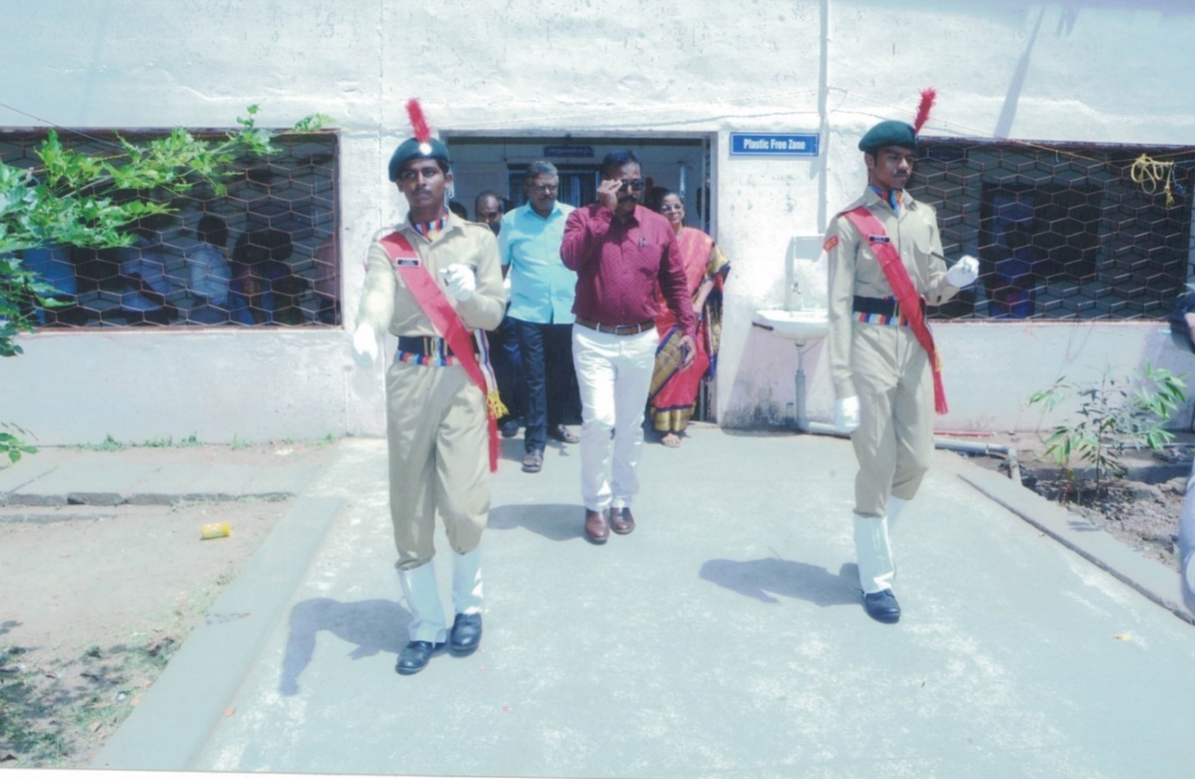
On 17. 03. 2023, Our College celebrated its Sports Day in the College auditorium. R.P. Ravichandran, District Sports Authority & Youth Welfare Organization was the Chief Guest. TheChief Guest was honored with the March past by NCC Cadets of Army wing.
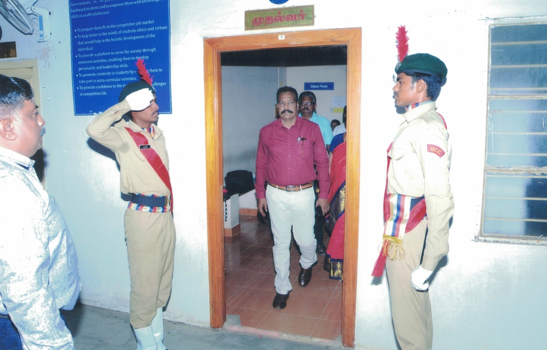
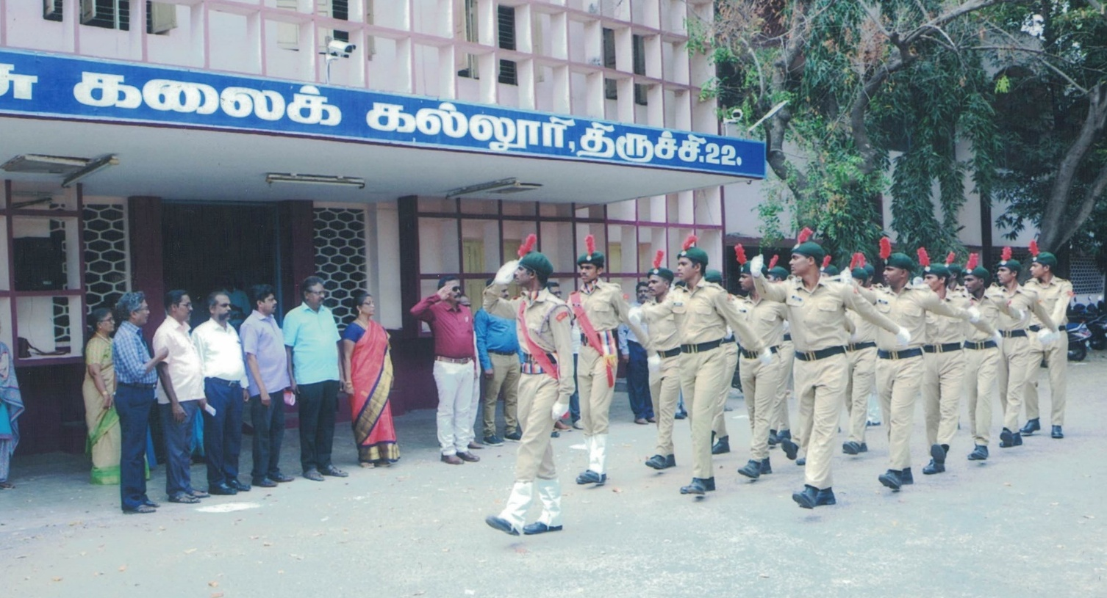

ANNUAL DAY 2023
(18. 03. 2023)
The Annual Day Function of Our College was Organized on 18.03.2023 . The Chief Guest for the Day was Thiru. Anbil Mahesh Poyyamozhi, Minister for School Education, Government of Tamilnadu. The Chief Guest was being Marched to the Dias by the NCC Cadets.
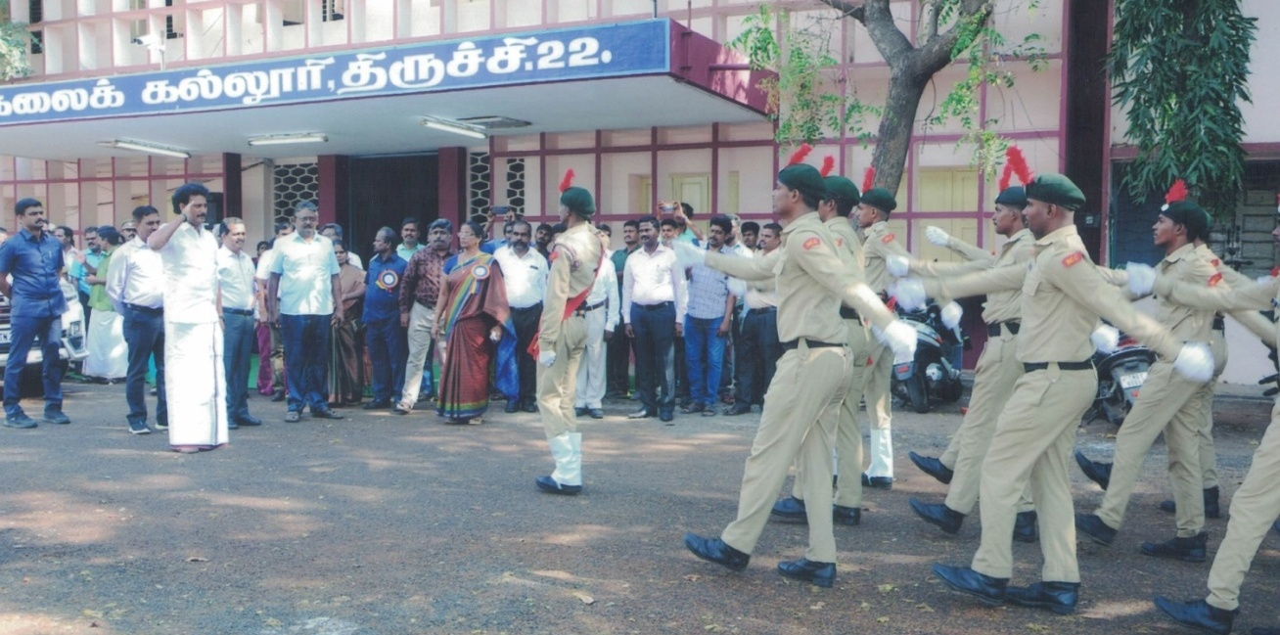

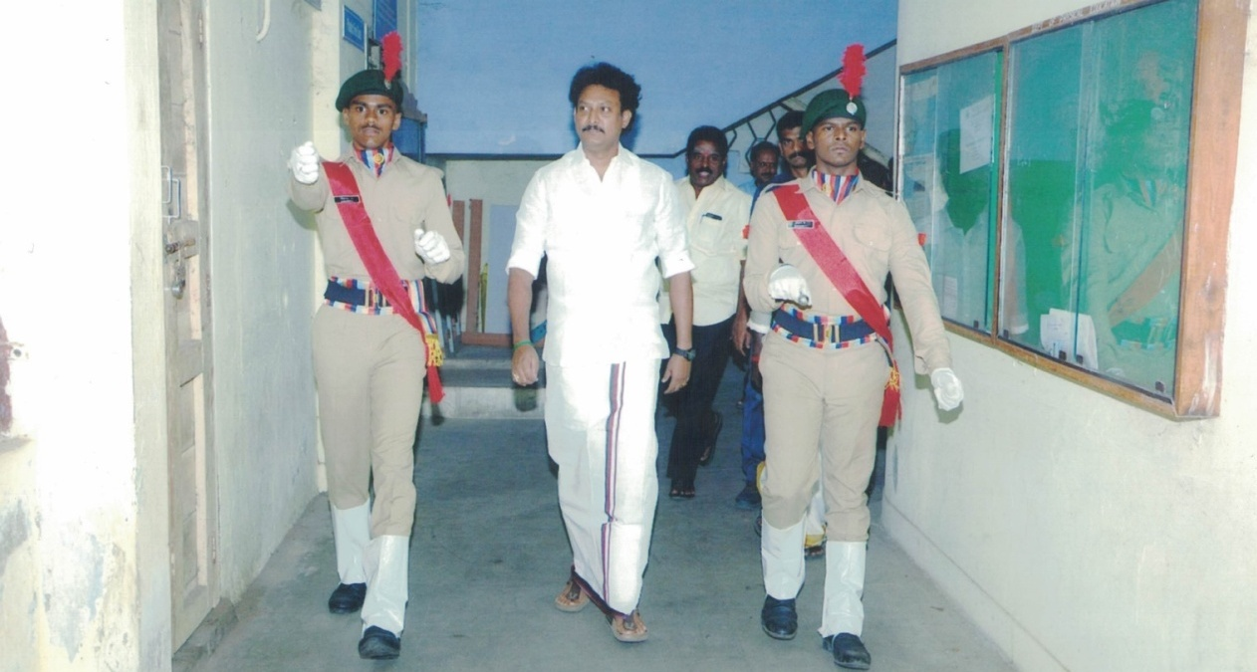

REPUBLIC DAY – 2024
NCC FLAG AREA (CULTURAL HERITAGE OF TAMIL NADU)
(26.01.2024)
